Final Report
1. INTRODUCTION
1.1 Project Overview
The project titled “Rainfall Prediction System Using Machine Learning” is a predictive analytics application designed to forecast whether it will rain tomorrow based on historical weather parameters.
The system uses machine learning algorithms to analyze weather attributes such as temperature, humidity, pressure, wind speed, and rainfall history. The trained model is integrated into a Flask-based web application, allowing users to input weather values and instantly receive a rainfall prediction (Rain / No Rain).
By combining data preprocessing, model training, and web deployment, the project transforms raw weather data into a practical and user-friendly prediction tool.

1.2 Purpose
The primary objective of this project is to develop a reliable rainfall prediction system that assists:
• Farmers in crop planning
• Agricultural planners in irrigation management
• Researchers analyzing climate trends
• Individuals interested in weather forecasting
The system empowers users to:
• Predict rainfall probability
• Reduce agricultural risks
• Make informed irrigation decisions
• Improve preparedness for weather changes

2. IDEATION PHASE
2.1 Problem Statement
Weather conditions are unpredictable and highly dynamic. Farmers and planners often rely on general weather forecasts, which may not provide sufficient accuracy for localized decision-making.
Key challenges include:
• Difficulty analyzing multiple weather parameters
• Lack of simple predictive tools for rainfall
• Dependence on generalized weather forecasts
• Limited access to machine learning-based prediction systems
There is a need for a simple, accessible, and reliable rainfall prediction tool.

2.2 Empathy Map Canvas
• Says:
• “Will it rain tomorrow?”
• “Should I irrigate my crops today?”
• Thinks:
• “Is rainfall prediction accurate?”
• “Can I trust the forecast for planning?”
• Does:
• Checks weather apps daily
• Monitors temperature and humidity
• Consults agricultural advisors
• Feels:
• Uncertain about weather changes
• Anxious about crop damage
• Concerned about water usage
2.3 Brainstorming
During brainstorming, multiple approaches were considered:
• Statistical forecasting
• Regression-based models
• Classification algorithms
After experimentation, Random Forest Classifier was selected due to:
• High accuracy
• Better handling of complex data
• Robustness against overfitting
Flask was chosen for web deployment because:
• Lightweight and simple
• Easy model integration
• Suitable for academic projects

3. REQUIREMENT ANALYSIS
3.1 Customer Journey map
Typical journey of a farmer:
- Observe weather uncertainty
- Check weather forecast
- Seek prediction clarity
- Use rainfall prediction tool
- Make irrigation or crop decision
Our system supports stages 3 and 4 by providing instant ML-based predictions.

3.2 Solution Requirement
• Weather dataset collection (WeatherAUS dataset)
• Data cleaning and preprocessing
• Handling missing values
• Feature encoding and scaling
• Model training and evaluation
• Flask web integration
• Prediction output display

3.3 Technology Stack
• Python – Programming Language
• Pandas & NumPy – Data preprocessing
• Scikit-learn – Model training
• Random Forest Classifier – Prediction model
• Pickle – Model serialization
• Flask – Web application framework
• HTML/CSS/Bootstrap – User interface
4. PROJECT DESIGN
4.1 Problem Solution Fit
The main problem is uncertainty in rainfall prediction.
Our solution provides:
• Machine learning-based rainfall prediction
• Simple input form for weather parameters
• Instant prediction results
• Accessible web interface
This directly addresses user needs for reliable and quick forecasting.

4.2 Proposed Solution
The proposed system consists of:
• A trained Random Forest classification model
• A Flask web application
• Input fields for weather attributes
• Prediction result display page
When users enter weather parameters, the system:
- Preprocesses the inputs
- Sends data to the trained model
- Predicts Rain or No Rain
- Displays result instantly

4. Solution Architecture
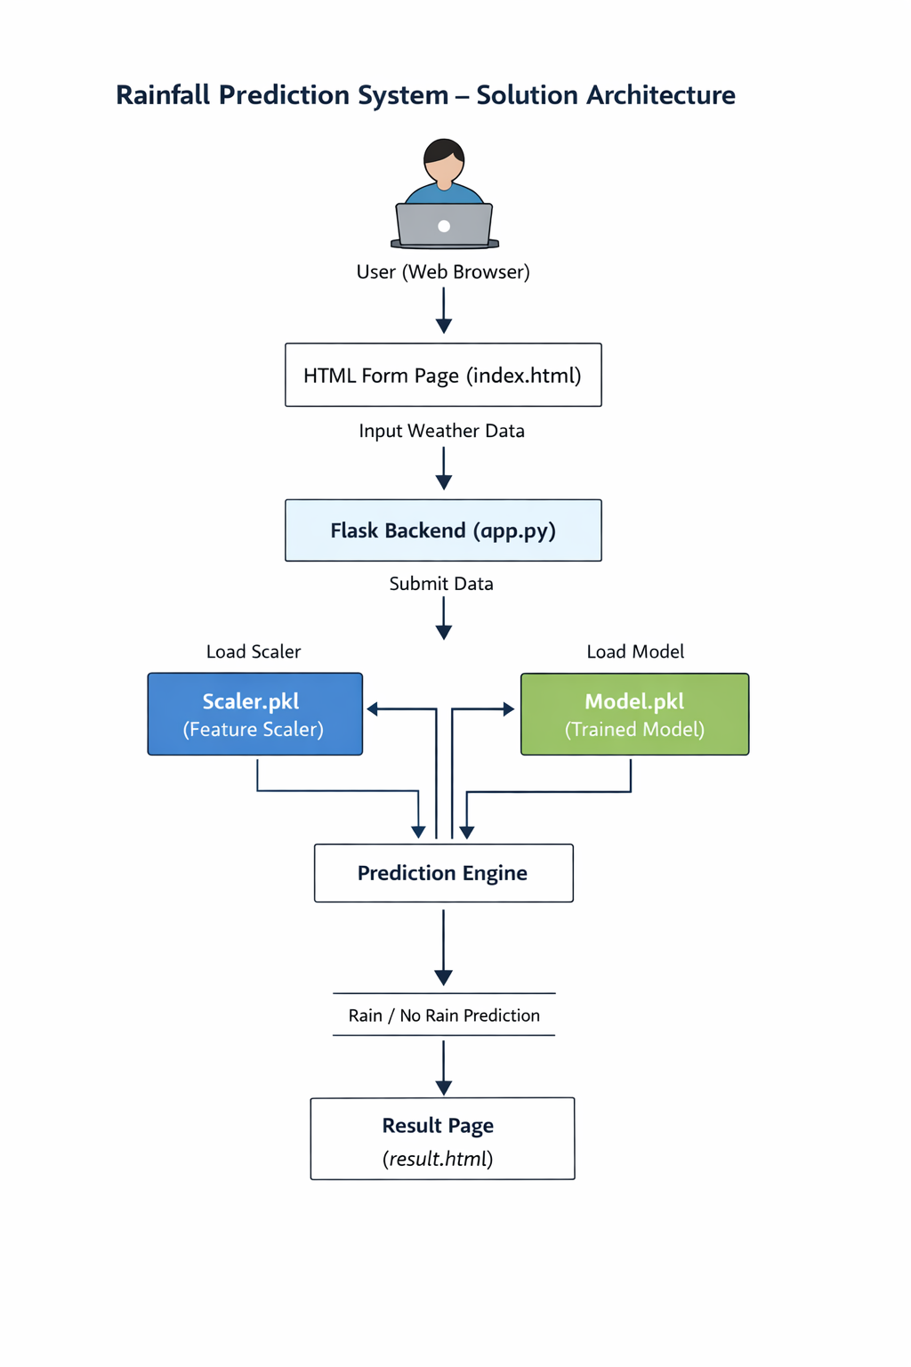
5. PROJECT PLANNING & SCHEDULING
5.1 Project Planning
Agile methodology with 3 sprints:
• Sprint 1: Data Collection & Preprocessing
• Sprint 2: Model Building & Evaluation
• Sprint 3: Web Application Development & Testing
Each sprint focused on incremental development and validation.

6. FUNCTIONAL AND PERFORMANCE TESTING

6.1 Functional Testing
Tested:
• Input validation
• Model prediction correctness
• Flask integration
• Result page rendering
• Multiple prediction stability
All test cases passed successfully.

6.2 Performance Testing
Performance evaluated based on:
• Page load time (< 3 seconds)
• Prediction response time (< 2 seconds)
• Stability under repeated requests
• Model accuracy (~81%)
The system performed within acceptable thresholds.

7. RESULTS
7.1 Output Screenshots
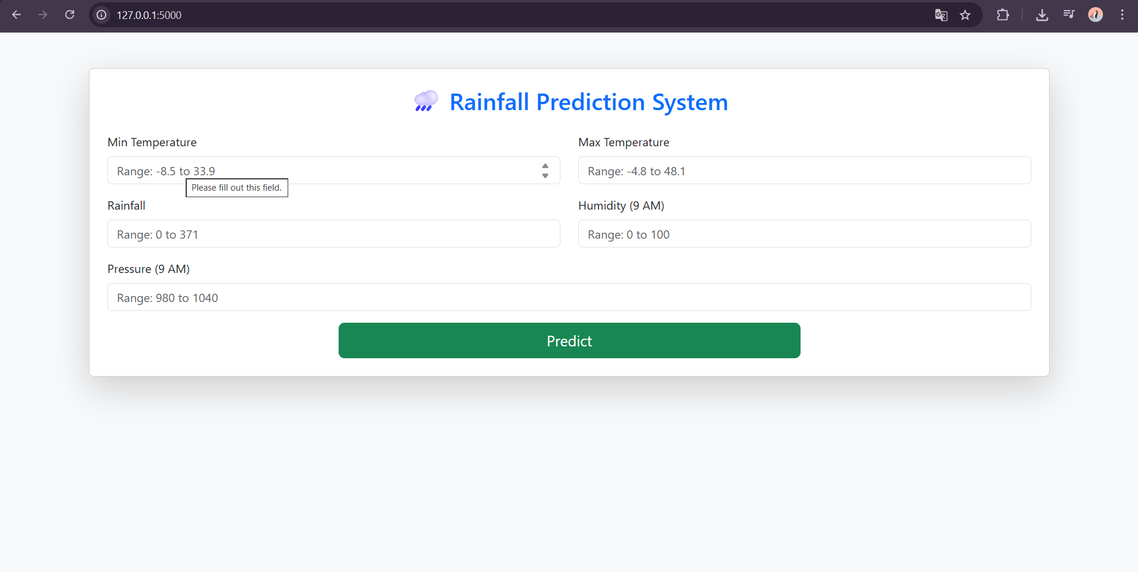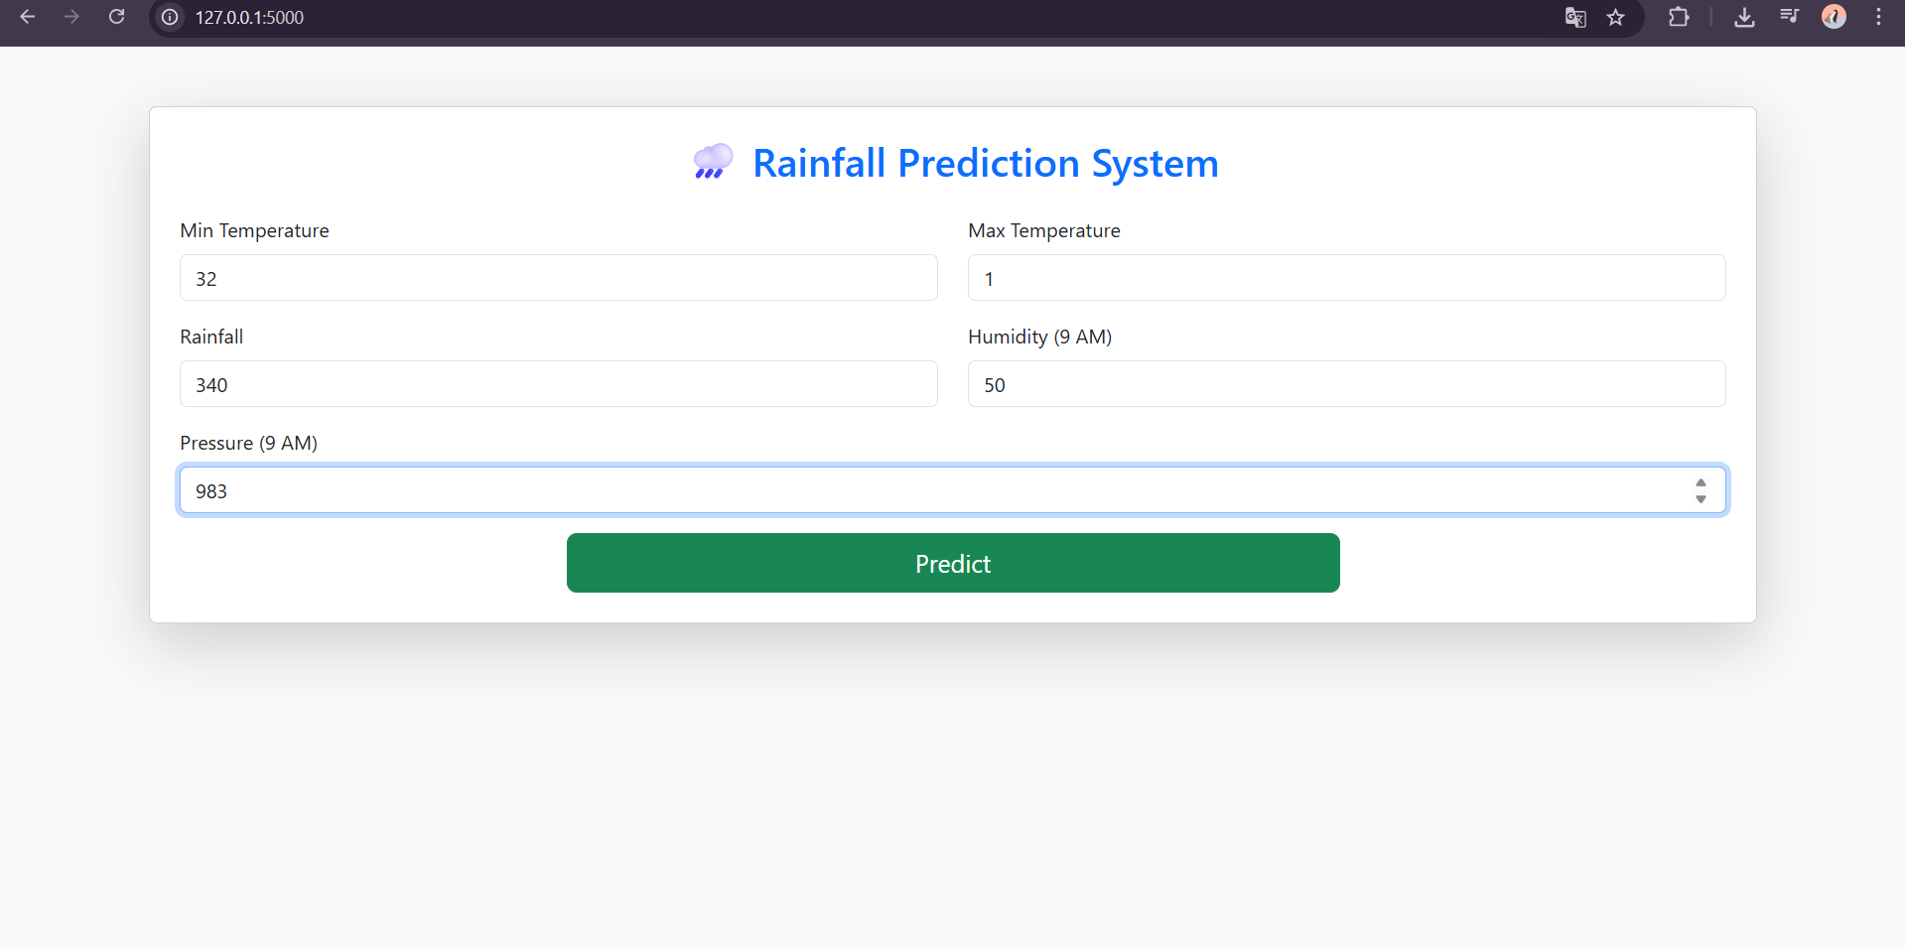
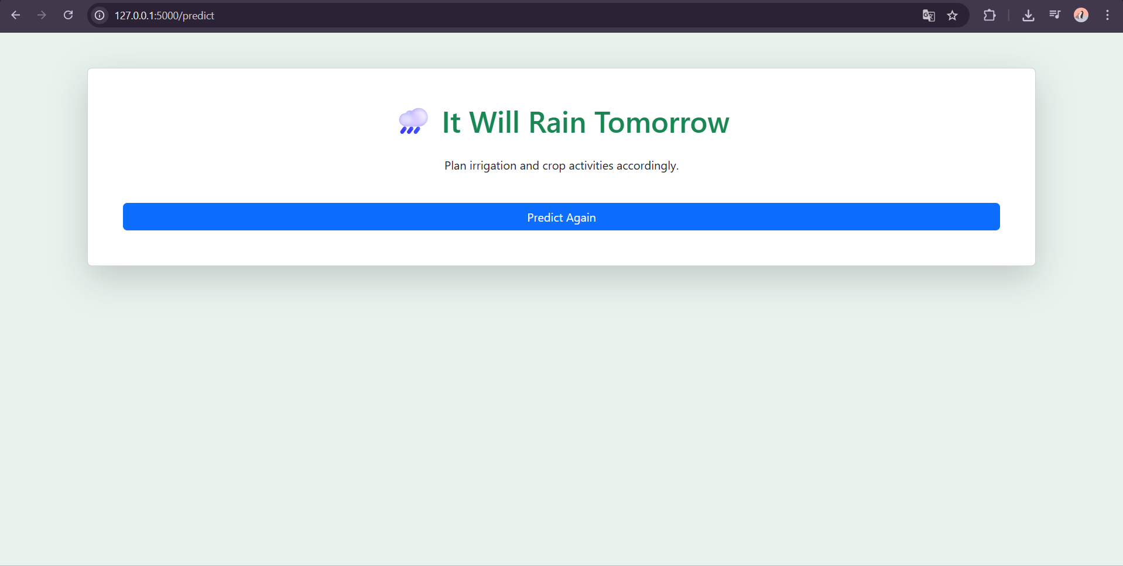
8. ADVANTAGES & DISADVANTAGES
Advantages
• Easy-to-use web interface
• Accurate prediction using Random Forest
• Fast response time
• Supports agricultural decision-making
• Lightweight and scalable
Disadvantages
• Depends on quality of historical dataset
• Accuracy may vary in extreme climate conditions
• Currently supports binary prediction only (Rain / No Rain)
• Not deployed on cloud (local deployment only)
9. CONCLUSION
The Rainfall Prediction System Using Machine Learning successfully transforms historical weather data into actionable insights. By integrating machine learning with a web application, the project provides an accessible, efficient, and practical tool for rainfall forecasting.
The system demonstrates how predictive analytics can assist in agricultural planning, reduce uncertainty, and support informed decision-making.
With further enhancements such as cloud deployment, live API integration, and probability-based forecasting, the system can be extended into a more advanced weather intelligence platform.

10. FUTURE SCOPE

• Integration of Real-Time Weather APIs
Incorporate live weather data (temperature, humidity, pressure, wind speed) to improve prediction accuracy and enable dynamic forecasting.
• Advanced Machine Learning Models
Implement deep learning models such as LSTM or ensemble techniques (XGBoost, Gradient Boosting) to enhance prediction performance and provide probability-based rainfall forecasts.
• Cloud & Mobile Deployment
Deploy the application on cloud platforms and develop a mobile-friendly interface to make rainfall predictions accessible to farmers, researchers, and the general public anytime, anywhere.
11. APPENDIX
Project Demo link : https://youtu.be/iBi1bUK9FGg?si=I4-FtK5khlAs3CNJ

